**User Manual – Resilio File Sharing System**

**1. Introduction**

The Resilio File Sharing System is a secure platform designed to streamline file management and sharing within your organization. This manual provides step-by-step guidance on how to navigate the system, register an account, and begin using its features.

**1.2 Purpose of This Guide**

This document covers the initial setup, including:

* User registration
* Account login
* Troubleshooting tips

2. **Getting Started**

2.1 Accessing the System

1. Open your web browser and navigate to the local LAN IP like http://192.168.1.100:8888.
2. The Welcome Screen will display two options:
   * Login (you need to register first because the first account is super admin)
   * Register (for super admin)

**ADMIN**

**3. Admin Registration**

3.1 How to Register

1. Click the **"Register"** button on the Welcome Screen.
2. Fill in the registration form:
   * **3.1.1 Username**: Enter a unique username.
   * **3.1.2 Password**: Create a strong password (use letters, numbers, and symbols).
   * **3.1.3 Confirm Password**: Re-enter your password for verification.
3. Click **"Register"** to complete the process.

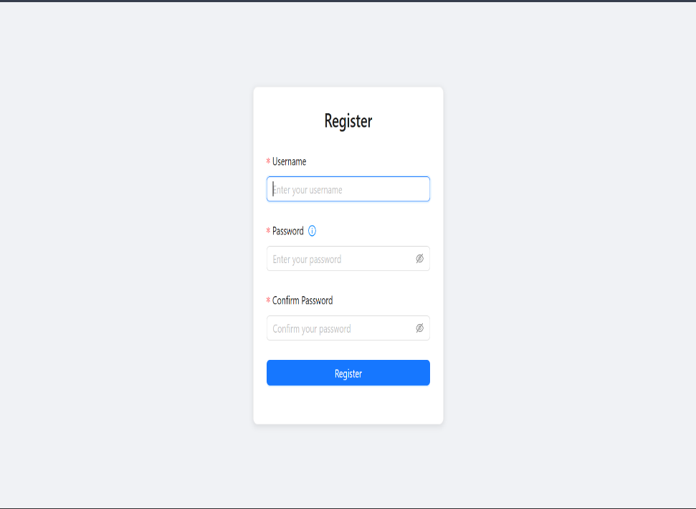

3.2 Registration Notes

* Usernames must be **unique** (no duplicates allowed).
* Passwords are case-sensitive (e.g., Password123 ≠ password123).
* The First Account is automatic super admin

**4. Admin Login**

4.1 How to Log In

1. On the Welcome Screen, click **"Login."**
2. Enter your credentials:
   * **4.1.1 Username**: Your registered username (e.g., admin).
   * **4.1.2 Password**: Your password (characters are hidden for security).
3. Click **"Log in"** to access your account.

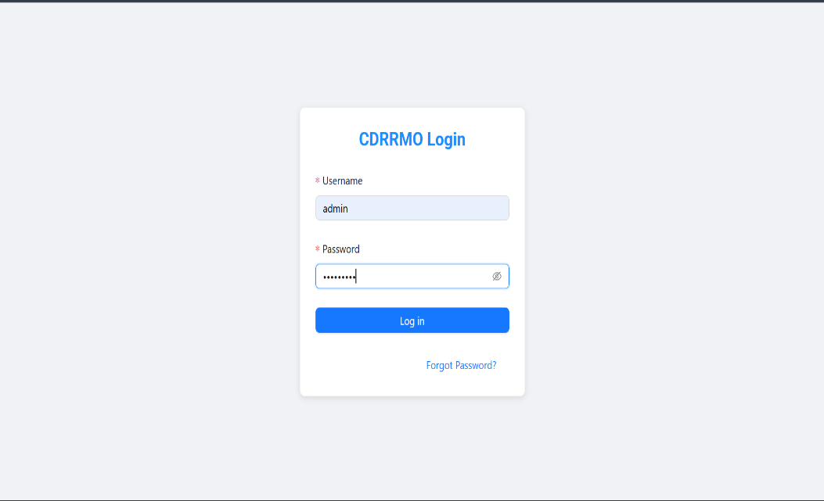

**4.2 Troubleshooting Login Issues**

* **4.2.1 Forgot Password?**: Click the link to reset your password(super admin and admin only) for regular users you need to contact the admin to reset your password.

**4.3 Logout**

* **Admins & Users:** Click **"Logout"** in the top-right corner to securely exit.

**5.Administrator Function**

**5.1 Dashboard Navigation**

* **5.1.1** Dashboard: System overview
* **5.1.2** User Management ( Adding, Edit and Remove User)
* **5.1.3** File Manager ( View, Edit, Move, Upload, Delete and Copy File)
* **5.1.4** Settings

**5.2 User Management**

**5.2.1 How to add User?**

5.2.2 Adding Users

1. A screenshot of a computer

   AI-generated content may be incorrect.Navigate to **User Management** → **Add New User**.

2.Enter:

* + Username
  + Password

3.Click **Add** → User appears in the list

NOTE: If the user was created then you give it the username and password to the office member to log in in resilio system.

5.**2.3 Editing Users**

5.2.4 How to Edit

1. Locate user in **User List**.
2. Click make admin/ revoke admin (to change the role)
3. Click **Edit** → Modify details (e.g., reset password,).

4.Click Update to save

**6. File Management**

**6.1 Folder Structure**

Three default folders:

1. **Operation**
2. **Training**
3. **Research**

**Note**: All file actions require a folder to be selected first.

* 1. A screenshot of a computer

     AI-generated content may be incorrect.**Uploading Files**

6.2.1Select a folder → Click **Upload File**.

* + 1. **Choose files** via:
  + **Drag and drop** into the window
  + **Manual browse** (file picker)
    1. **Assign to User** (Appears after file Selection)
* Send To User : Select User from dropdown
* Instruction: Use a Prefined Template or type custom Instructions
  + 1. Click Upload
* Progress bar shows completion
* System notifies assigned user

**6.3 Viewing Files**   
Files are displayed with:

* **Name** (Click to preview)
* **Type** (e.g., PDF, DOCX)
* **Size** (MB/GB)
* **Actions** (Download, Copy, Delete,Move)

**6.4 Navigating Folders**

* **Go Up**: Returns to the parent folder.
* **Search**: Enter keywords to filter files (*supports partial matches*).
* **Assignment Fiter**: View Files assigned to specific user

7. **Admin Settings**

**7.1 Accessing Settings**

1. Navigate to:
   * A screenshot of a computer

     AI-generated content may be incorrect.**Resilio Admin** → **Settings** (from sidebar)

7.2 Key Configuration Options

* Admin Password:
  + Enter new credentials for admin access.
* Maintenance Mode:
  + Toggle to disable user access during updates.
* Max Upload Size (MB):
  + Set file size limits (e.g., 500MB).
* Shared Folder Path:
  + Define default storage directory (e.g., C:\ResilioShared).
* Detailed Logging:
  + Enable for troubleshooting.

7.3 Saving Changes

* Click Save Settings to apply.
* System restarts services if path/limits are modified.

Warning: Changes to folder paths may require file migration

**STANDARD USER OF SYSTEM**

**1. System Access**

1.1 Accessing the System

1. Open your web browser and navigate to the local LAN IP like <http://192.168.1.100:8888>.

Then you can see the log-in page of the system

1.2 Account Creation (Admin-Only)

1.Users cannot self-register

2.Contact your administrator to Create your username/password

**1.3 Login Procedure**

1.Enter admin-provided credentials:  
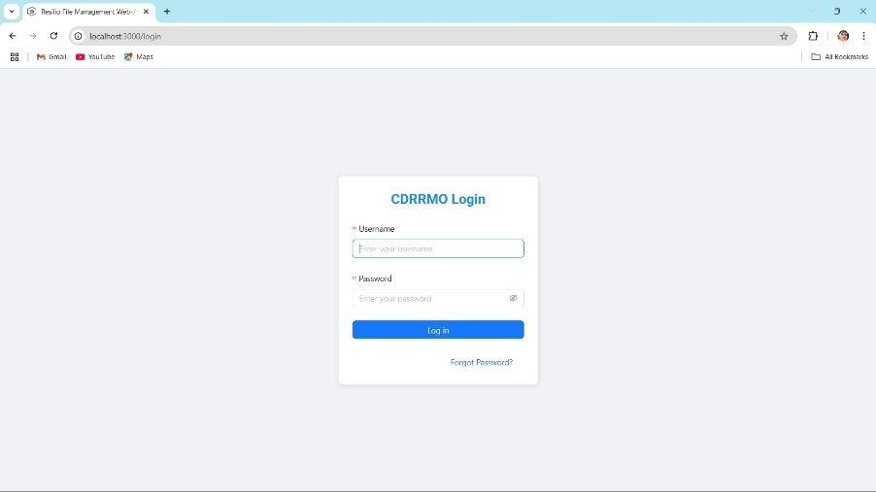  
*Note: Passwords are case-sensitive*

**2. Dashboard Overview**

**2.1 Navigation**

* **Home**: System announcements
* **Operation/Training/Research**: Department folders
* **Settings**: Personal preferences

**3. File Management**

**3.1 Uploading Files**

1. Navigate to target folder (e.g., "Operation").
2. Click **Upload File** or drag files:  
   A screenshot of a computer

   AI-generated content may be incorrect.  
    *Supports multi-file uploads with progress tracking.*

**3.2 Folder Operation (selected folder )**

* **Create Subfolders**:  
  A screenshot of a computer

  AI-generated content may be incorrect.
* **A screenshot of a computer

  AI-generated content may be incorrect.Move and Copy Items**: Duplicate files with modified names.

**4. Task Collaboration**

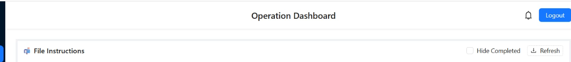**4.1 Viewing Admin Assignments**

* Files shared by admins display:
  + 📝 **Instructions** (below filename)
  + ⏰ **Deadlines** (if specified)
  + ✔️ **Completion checkbox**

**4.2 Marking Tasks Complete**

1. Locate assigned file in folder.
2. Click checkbox to confirm completion

*Admins receive real-time status updates*.

**5. Personal Settings**

*Settings are device-specific.*

**5.1 Customization Options**

* **Dark Mode**: Reduce eye strain
* **Notifications**: Enable/disable alerts

6. Log Out

6.1 How to Log out?

Click the log-out button in the right top.